

**National University of Computer and Emerging Sciences**

Software Engineering

**“Deliverable # 2 – Iteration-1 – Sprint 1”**

**E-Learning System**

**STUDENTS NAME AND REGISTRATION NUMBERS:**

Muhammad Umaid Khakwani i19-0666

Hanzla Sibghat i19-0505

Saad Ahmad Jilani i19-0615

**DEGREE PROGRAM:** BS-CS-2019

**SECTION:** D

**SUBJECT NAME:** Software Engineering

**DATE OF SUBMISSION: March 25, 2022**

**SUBMITTED TO:** Dr. Maryam Abdul Ghafoor

__**____________________________________________________________**

# Part B:

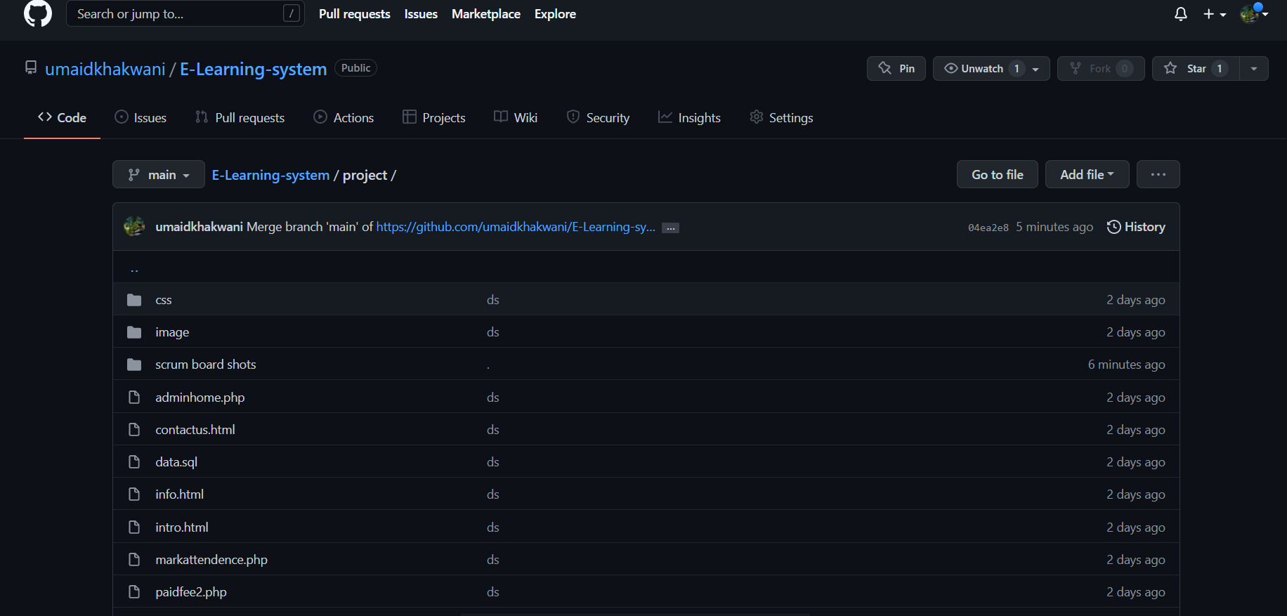<https://github.com/umaidkhakwani/E-Learning-system/tree/main/project>

# Part C:

**BLUE Print of Architecture**

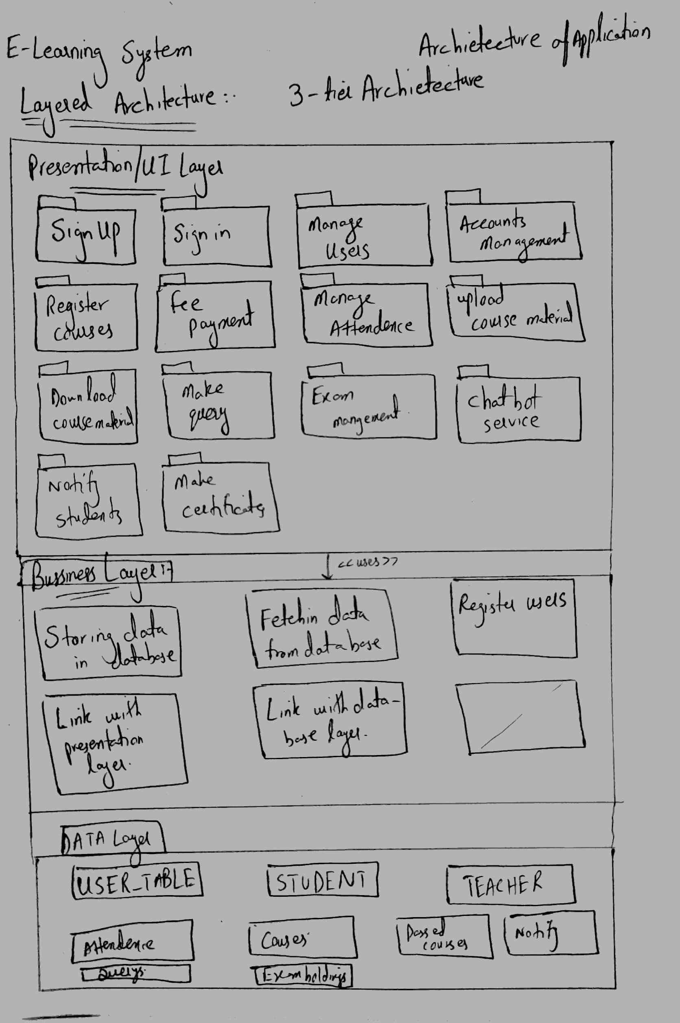

# Part D:

**CRC**



# Part E (i):

snapshot 1:

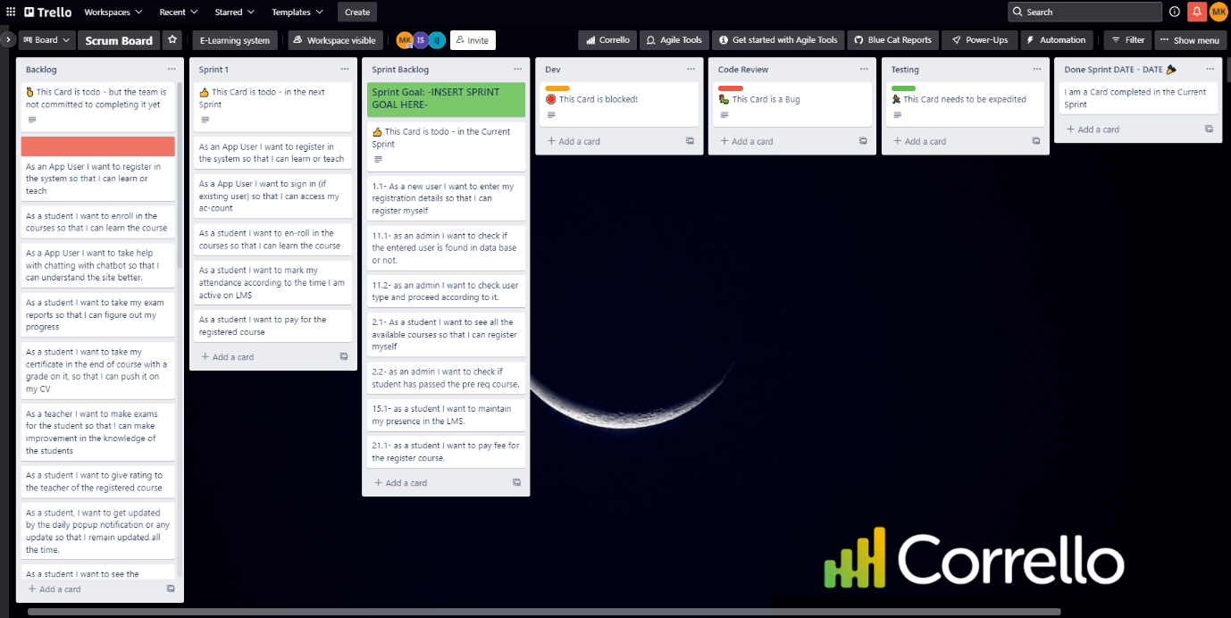

snapshot 2:

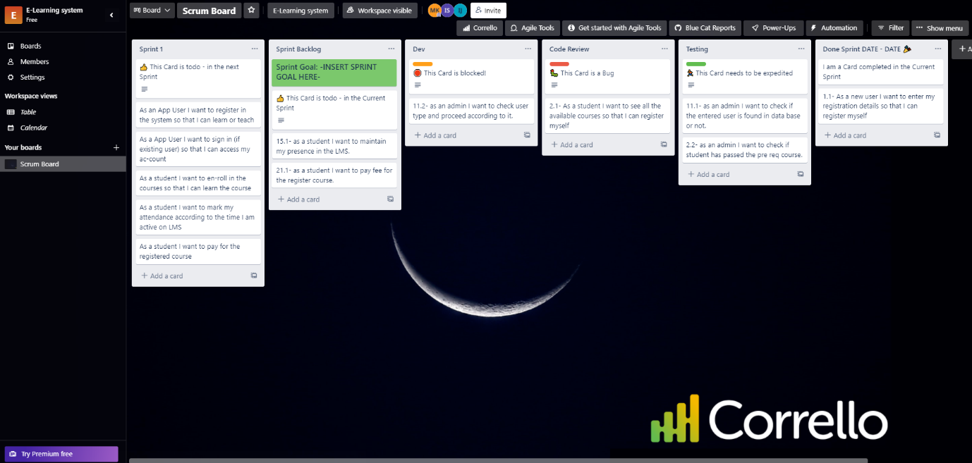

snapshot 3:

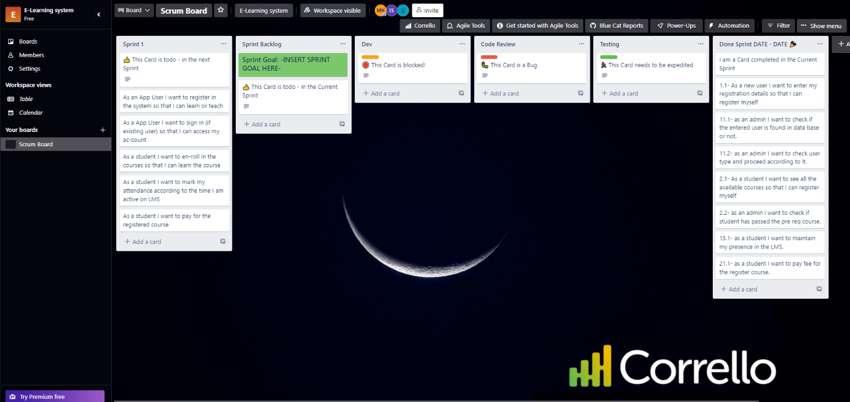

Snapshot 4:

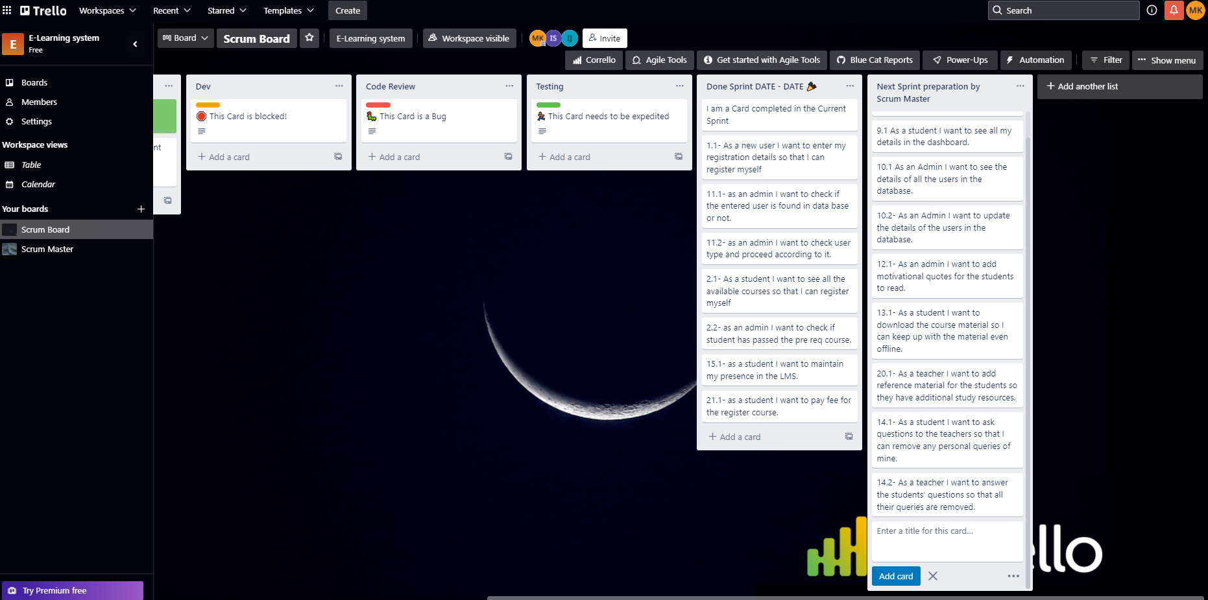

# Part E (ii):

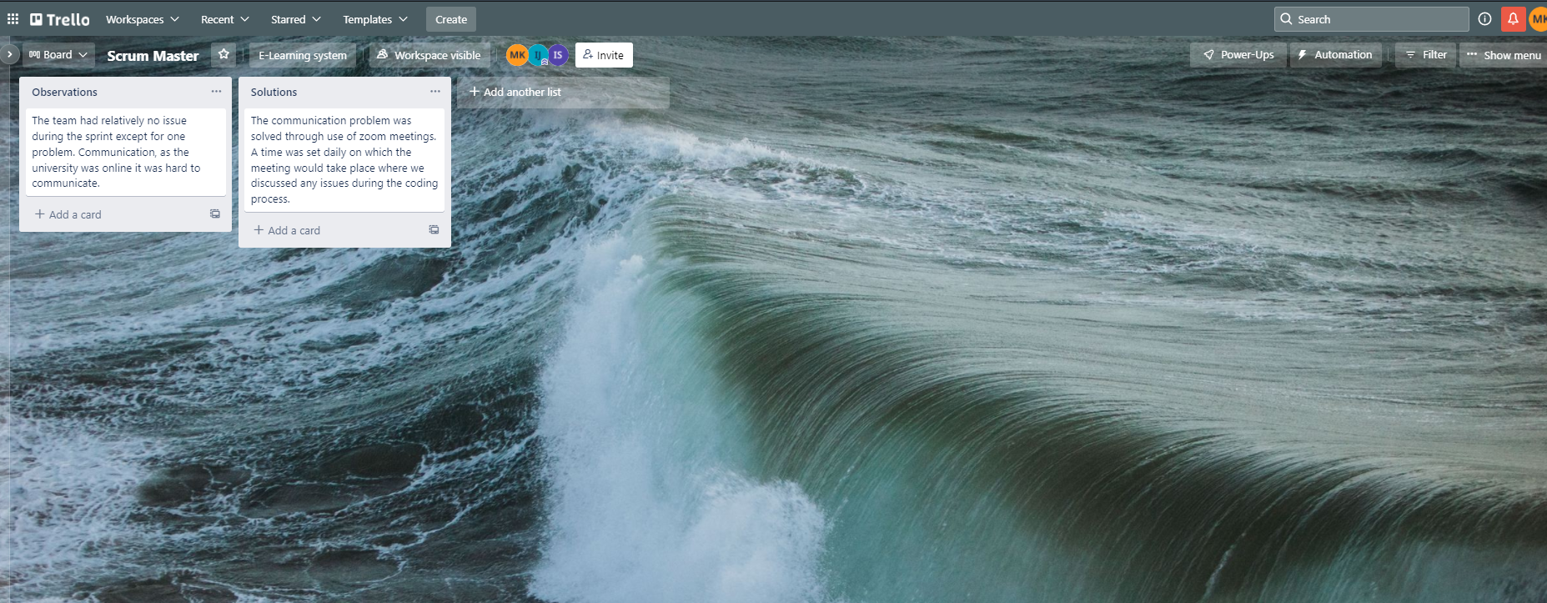

# Part E (iii):

No leftover.

# Part E (iv):

**Burn Down Chart**

# Part F:

**Sprint 2: -**

|  |  |  |  |
| --- | --- | --- | --- |
| **User Story** | **Sub-story** | **Tasks** | **Time** |
| 22 | * 1. As a teacher I want to upload course material for the students. | 22.10 check the total courses and make pages of all courses and upload course material on it. | 22.10 2 hours |
| 9. | 9.1 As a student I want to see all my details in the dashboard. | 9.10- create a page which contains attendance, marks and grade of the student accessing it. | 9.10 2 hours |
| 10. | 10.1 As an Admin I want to see the details of all the users in the database. | 10.10 – The admin is shown details of all the students and teachers in the database. | 10.10 1 hours |
| 10.2- As an Admin I want to update the details of the users in the database. | 10.20- Admin can change course teacher, student grade/attendance. Admin can also delete course from the database. | 10.20 1 hour |
| 12. | 12.1- As an admin I want to add motivational quotes for the students to read. | 12.10- First web page for motivational quotes will be created where the admin will upload the quotes. | 12.10 1 hour |
| 13. | 13.1- As a student I want to download the course material so I can keep up with the material even offline. | 13.10 Student will be given option to download course material from the web page. | 13.10 2 hours |
| 20. | 20.1- As a teacher I want to add reference material for the students so they have additional study resources. | 20.10 Make pages for all courses and upload additional reference material on it. | 20.10 1 hour |
| 14. | 14.1- As a student I want to ask questions to the teachers so that I can remove any personal queries of mine. | 14.10 Make Table for Questions in the Database.  14.11 Make page where a form will exist.  14.12 The information of the form will be stored in the Questions Table. | 14.10 30 minutes  14.11 1 hour  14.12 30 minutes |
| 14.2- As a teacher I want to answer the students’ questions so that all their queries are removed. | 14.20- Make Table for Answers in the Database.  14.21- Teacher will be shown the Question asked to him/her.  14.22- Form will be created for the Answer.  14.23- The information will be stored in the Answers table in the Database. | 14.20 30 minutes  14.21 30 minutes  14.22 1 hour  14.23 30 minutes |

**Roles and Duties for upcoming (Sprint#2)**

|  |  |  |
| --- | --- | --- |
| **Name** | **Role** | **Duty** |
| Umaid Khakwani | Product Owner | Manage Product and Sprint Backlog, Organize Work, Reporting |
| Hanzla Sibghat | Scrum Master | Manage Scrum Process, Enforce Rules, and Remove Blocks |
| Saad Jilani | Scrum Team | Contributed to the creation of user stories |